

Faculty of Engineering

Department of Electronic & Telecommunication

Performance Enhancement by Beamforming in Visible Light

Communication for Multiple Users

Final Year Project Proposal

Supervised by

Ms.Dilanka de Silva

prepared by

S. M. S. M. Bandara (21ug0481)

M. N. K. M. Bandara (21ug0496)

Table of Contents

Acronyms and Abbreviations 3

Abstract 4

Project Background 5

Beamforming in VLC 6

1.1 Introduction 6

1.2 Aim and Objectives 6

1.3 Project Management 7

1.3.1 Scope Management 7

1.3.2 Budget Management 7

1.3.3 Time Management 8

Literature Review 9

Methodology 10

Conclusion 12

Reference 13

# Acronyms and Abbreviations

VLC - visible light communication

LED - light emitting diode

LD - lasor diode

SLM - spatial light modulator

AP - access point

MEM - micro electro mechanical

# Abstract

Indoor wireless communication presents challenges such as limited coverage, interference, and scalability. Visible Light Communication (VLC) has emerged as a promising solution, leveraging visible light for data transmission. However, conventional VLC systems face limitations, including coverage range and susceptibility to interference. This project aims to address these challenges by enhancing VLC with beamforming techniques, utilizing photodiodes and LEDs.

The project begins with a comprehensive literature review to explore previous research in VLC, beamforming techniques, photodiodes, and LEDs. By synthesizing existing knowledge, the project identifies gaps and opportunities for innovation in VLC system design. The methodology involves system design, hardware and software development, and performance evaluation. Through integration of photodiodes for reception and LEDs for transmission, the project aims to leverage their complementary strengths to achieve optimal performance in terms of coverage, reliability, and scalability.

The main challenge addressed by the project is the inherent limitations of current VLC systems, such as limited coverage and susceptibility to interference. Through beamforming using photodiodes and LEDs, the project seeks to enhance VLC performance and enable adaptive and efficient communication in dynamic indoor settings.

In conclusion, this project holds great potential to advance the field of indoor wireless communication. By leveraging beamforming techniques with photodiodes and LEDs, it aims to overcome the limitations of conventional VLC systems and enable more efficient and reliable communication in indoor environments.

# Project Background

In today's digital era, the demand for high-speed and reliable wireless communication in indoor environments is ever-increasing. Traditional radio frequency (RF) communication technologies face challenges such as limited bandwidth, interference, and security vulnerabilities. To address these challenges, researchers have been exploring alternative wireless communication solutions, one of which is Visible Light Communication (VLC).

VLC utilizes light-emitting diodes (LEDs) to transmit data through modulated light signals. This technology offers several advantages, including high bandwidth, immunity to electromagnetic interference, and enhanced security due to its limited range. As a result, VLC has gained traction in various applications such as indoor positioning, data transmission, and Li-Fi internet access.

However, despite its potential, conventional VLC systems have limitations that hinder their widespread adoption. These limitations include limited coverage range, susceptibility to interference from ambient light sources, and scalability issues in dynamic indoor environments. To fully realize the benefits of VLC and address these challenges, innovative solutions are needed.

The proposed project seeks to enhance VLC performance by leveraging beamforming techniques using photodiodes and LEDs. Beamforming is a signal processing technique used to enhance the performance of communication systems by directing signals towards specific receivers. By dynamically adjusting the direction of transmitted light beams, beamforming can improve coverage, reliability, and data rates in VLC systems.

Through the integration of photodiodes for reception and LEDs for transmission, coupled with beamforming techniques, the project aims to overcome the limitations of conventional VLC systems. By optimizing signal transmission, enhancing signal-to-noise ratio, and mitigating the effects of multipath propagation, the project seeks to enable more efficient and reliable communication in indoor environments.

Chapter 1

# Beamforming in VLC

## Introduction

Since thousands of years, light has been utilized to communicate information. Optical communication was later made possible by the construction of signaling towers. A new name will come in the future called VLC with many features. Visible light communications (VLC) are the name given to an optical wireless communication system that carries information by modulating light in the visible spectrum. Simply it is a technique which uses visible light to transmit messages from one place to another. The spectrum used by VLC systems is approximately from 430 THz to 790 THz, and there is no interference between the VLC systems and the existing radio frequency systems. With the rise of high-power light emitting diodes (LEDs) in the visible spectrum, interest in VLC has exploded. There are some characteristics which motivate light for data transfer. They are, extra power is not necessary for data transfer, easy to maintain data security in indoor area on physical layer, and visible light is not harmful to the human body.

Beam forming is a technique used to enhance the performance of VLC. It is focusing energy towards a receiver. Beam forming techniques used in cellular phones and other wireless communication technologies have improved over time to produce increased cell density and increase signal to noise ratio. In here, beam steering using multiple receiver elements is a technology which can get more signals from user and make a single beam to increase the data rate. It is very important to identify user location at firstly. Here we suggest a method to get maximum data rate, reliable, controllable, can easily processed and keep good coverage between access point and users. And also, this is not a complex in hardware, so can easily deploy in indoor area.

## Aim and Objectives

* + Using beam steering in VLC to unify the user experience in the area under consideration.
  + Develop an algorithm to identify exact user location.
  + Implement a bi directional VLC system with beam steering capability.
  + Develop hardware components for the VLC system, including LED arrays and photodetectors.
  + Implement beamforming algorithms for dynamic adjustment of transmitted light beams.
  + Evaluate system performance through simulations and practical experiments and Optimize beamforming parameters to maximize throughput and minimize interference.

## 1.3 Project Management

### 1.3.1 Scope Management

1. Analyzing project topic area - **Both**

2. Develop algorithms near the access point and user side.

* Find maximum receiving signal level to receiver elements in access point - **Methsilu**
* Find direction of user, relevant to received signal levels - **Sanujaya**
* Processing at user side - **Methsilu**

1. Implement the VLC system
   * Implement the access point side (multiple receiver part) - **Methsilu**
   * Implement the access point side (steering transmitter) - **Sanujaya**
   * Implement the user side - **Sanujaya**
2. Study at what angles of photodiodes should be installed - **Methsilu**
3. Testing and troubleshoot – **Both**

### 1.3.2 Budget Management

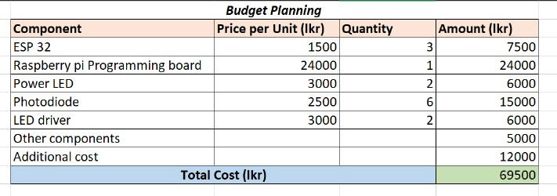

Figure Budget Management table

### 1.3.3 Time Management

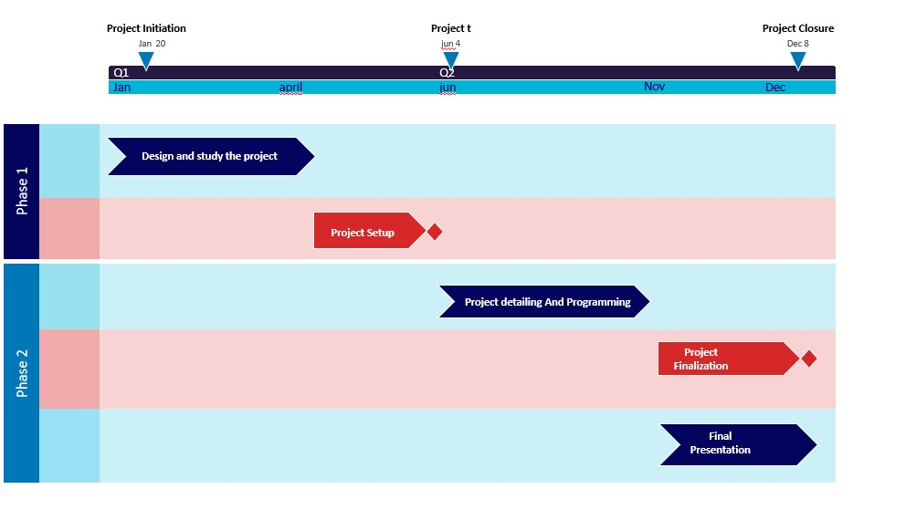

Figure Time management table

Chapter 2

# Literature Review

There is growing interest in indoor visible light communications (VLC) due to its potential to combine illumination and communications. In earlier time, there was WLED (white light emitting diode) commercially available at low data rate. After to obtain higher data rate, wavelength division multiplexing (WDM) was investigated. There are some beam-forming techniques to used and it can flexibly deliver a high-capacity communication channel to end-users in indoor area also it can be an attractive option to consider in VLC systems to enhance the system performance.

Beam forming through spatial light modulator (SLM) is one method that is a device, focused light on desired target. The LED is covered by a SLM to control the LED light beam. SLM focuses the LED light on each user device according to their locations. [1] The User device location can be detected by using a location-detecting algorithm. Using electronically controlled mirrors in front of the receiver, a VLC beam steering array can be created. Colour LDs (Lasor diodes) can be used for that method. MEMS mirror is rotating device by capturing the beam of light prior to send the receiver. In LDs using systems’ performance high than LED systems. [2] But LDs are harmful to human, so it is not suitable method in using indoor area directly. That two methods are complex and slightly more expensive.

There are another inexpensive way to use in beam forming. One of that method is tilting Piezo electric actuator in both transmitter and receiver. By tilting LEDs or lenses (MEM mirrors) they can steer the beam direction towards user location. These technologies result in a huge receiver that cannot be utilized in mobile devices and can only be employed in fixed systems with low transmission rates. [3] Wavelength division multiplexing (WDM) is not expensive and noncomplex beam former. It provides for a reduction in the number of optical sources by combining dispersive and non-dispersive time delays in order to make better use of WDM. As usual in WDM beam forming architectures, to steer the beam, the dispersive time delay has to be changed. [4]

Receiver diversity is often used to improve reception of signals from user. Angle diversity in receiver technique is method of enhancing beam adaptation. It gives higher data rates. [5] Angle diversity receiver is combination of detectors (photodiodes) that point to different directions to obtain strongest signals. [6] It is fixed, but it covers whole area by pointing receivers to cover that area.

The purpose of this article is proposed a novel reliable method of beam forming with steering access point (transmitter) or user (receiver) to find the exact location of the user before send signals using an algorithm.

Chapter 3

# Methodology

The access point (transmitter) consists of multiple receiver elements (photo detectors), LEDs and fixed the location also does not steer. The 3 users (3 receivers) has a receiver element, LED and may change the location time to time. System is bi directional, so both access point and user have receiver element and transmit element (source). [7]

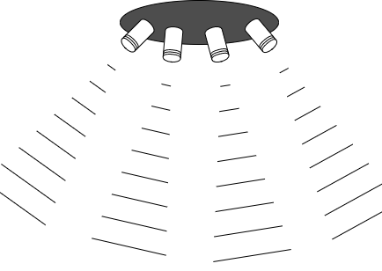

Figure 3: Structure in receiver elements of access point with four branches

Firstly, transmitter wants to identify the users location for continuous strong connection. Therefore, access point sends a signal to users and users detects it, then users send signal to access point via it’s transmit element. There are multiple receiver elements in access point and the users signal detects from that all receivers. In access point, after the first signal comes and the algorithm looks in the direction and turns, next signal can be sent. Due to variations in signal received levels, the access point identifies location of users by a developed algorithm. For that, each receiver wants separate identifiers to decide areas using receiver levels.

To increase the system performance, can increase the partitions in room. From multiple receivers can increase the data rate also. Here the proposed system try to use four receiver elements in access point. In the access point needs to be processed to find out which receiver element gets high signal levels. After identifying exact location of the users, the LED turns to the users. That steering is done using actuators. The indoor area can be separated as below.

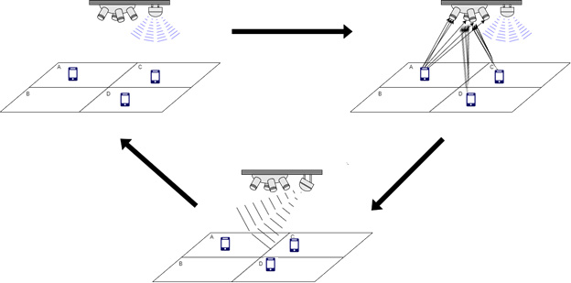

Figure 4: System diagram of a situation

The 3 Users side has less processing .When the user side is more complex, the power usage is higher and large in size. The system flow is below.



Figure 5:Flow diagram of access point



Figure 6:Flow diagram of receiver (users)

Receiver diversity in access point is a new technique in beam steering of VLC. The proposed method is reliable, controllable and we use receiver diversity as secondary advantage. There are some advantages in system by using receiver diversity. It can receive signals in low coverage, can increase the uplink coverage, can even get a signal from users in far away and covers more than the operating area. This method can be used to recover a good, strong receiver signal by combining more beams. Future reports will present receiver diversity techniques and system performance enhancement methods.

Chapter 4

# Conclusion

In conclusion, the proposed project to enhance Visible Light Communication (VLC) with beamforming techniques using photodiodes and LEDs holds significant promise for advancing indoor wireless communication. By addressing the challenges of limited coverage, interference, and scalability inherent in conventional VLC systems, this project aims to unlock new opportunities for efficient and reliable communication in indoor environments.

Through a thorough literature review, gaps and opportunities for innovation in VLC system design have been identified, providing a solid foundation for the project's methodology. The integration of photodiodes for reception and LEDs for transmission, coupled with beamforming techniques, offers a synergistic approach to overcoming the limitations of current VLC systems.

The project's methodology, encompassing system design, hardware and software development, and performance evaluation, is designed to systematically address the identified challenges and validate the effectiveness of the proposed solution. By leveraging the complementary strengths of photodiodes and LEDs, the project aims to achieve optimal performance in terms of coverage, reliability, and scalability.

# Reference

1. R. L. S. Neff, J.A.; Athale, “Two-dimensional spatial light modulators: a tutorial,” 1990.
2. A. Q. C. Z. W. F. G. O. D. Chun, Hyunchae; Gomez, “A wide-area coverage 35gb/s visible light communications link for indoor wireless applications,” in *Scientific Reports*, 2019.
3. C. G. I. P. N. SaidEroglu, Yusuf; Kumar Anjinappa, “Slow beam steering for indoor multi-user visible light communications.” in *IEEE/OSA Journal of Optical Communications and Networking*. 2018 IEEE 19th International Workshop on Signal Processing Advances in Wireless Communications (SPAWC) - Kalamata, Greece, 2018.
4. M. T. I.-L. C. M. J. M. I. V. E. . L. Vidal, B., “Simplified wdm optical beamforming network for large antenna arrays,” in *IEEE Photonics Technology Letters*, 2006.
5. M. Y.-H. S. Yue Zhang; Cosmas, J.; Bard, “Diversity gain for dvb-h by using transmitter/receiver cyclic delay diversity,” 2006, p. 464–474.
6. S.-W. C. C. S. Nuwanpriya, Asanka; Ho, “Angle diversity receiver for indoor mimo visible light communications.” IEEE 2014 IEEE Globecom Workshops (GC Wkshps) - Austin, TX, USA, 2014.
7. A. M. Hussein, AT and M. Elmirghani, “Fast and efficient adaptation techniques for visible light communication systems,” in *IEEE/OSA Journal of Optical Communications and Networking*. [online]. Available: https://doi.org/10.1364/JOCN.8.000382, 2016.